**NOAA Ship THOMAS JEFFERSON Procedure Document**

Procedure:

**POS M/V GAMS Calibration**

Creation Date:

04/13/2022

Revision Date:

Software used:

**MV-POSView 10.x**

Procedure Number:

**TBD**

Approved:

**TBD**

# Overview and Scope

This brief write-up is a simplified procedure for conducting a GAMS calibration on any

of the three POS M/V 320 v5’s aboard *Thomas Jefferson*. For a more detailed explanation consult the latest manual available.

# Procedure Inputs and Outputs

## Inputs:

## Outputs:

# Procedure

1. Ensure that the correct settings are in place for normal POS operations including:

Correct lever-arm offsets are entered- check with CHST/OPS

Receiving differential correctors- Nav. Status should say Pri. DGPS

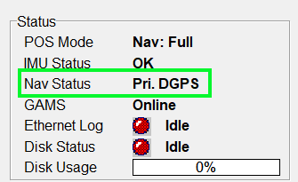

2. Open the Excel POS MV Cal Report found here: "K:\Standard_Operating_Procedures\05_HSRR\Reference Files\Vessel_POS_MV_Cal_Report_20YY.xls" You can start filling out the information and populating screen shots before starting the calibration.

3. Go to View > GAMS Solution. Check to ensure:

* GAMS Heading Accuracy is below 0.5
* PDOP is below 3.0
* SV’s in Solution is >5

Keep this window open during the calibration procedure.

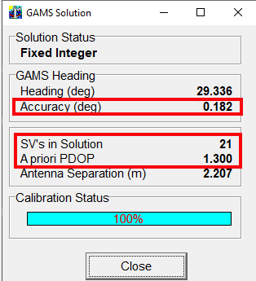

4. Press the Connect button to connect to POS 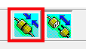. Navigate to Settings > Installation > User Accuracy and ensure values are set as seen below.

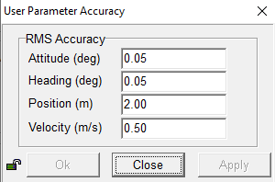

5. When ready to perform the calibration, press the Stand By button . This will zero out all of the attitude readings and turn the Accuracy lamps to red.

6. Press the NAV button to the right of the Stand By button . This will reset the status of the attitude sensors and the Accuracy lamps will start turning back to green. Some may remain red- this is ok.

7. Once the above requirements are met, navigate to Settings > GAMS Calibration Control > Start

8. When the GAMS status displays CAL Requested, begin driving aggressive S and figure 8 turns at high speed. Keep an eye on the GAMS status during this time.



9. When the Gams status displays CAL in Progress, drive a straight line until the GAMS status changes to CAL Complete. You will see a progress bar at the bottom of the GAMS Solution window that will show the progress of the calibration and will show 100% when finished.

10. Complete the remaining sections of the POS MV Cal Report. Compare the initial GAMS Baseline Vector values to the ones achieved after calibration. Consult with CHST/OPS if the values differ by a few centimeters or more. If instructed, perform another calibration.

11. If the baseline vector values are close to the initial values, or if CHST/OPS deem the final values appropriate, close all windows and click the disconnect button. **Click OK to save changes**.

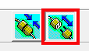

12. Click File > Save POS Config to save a new configuration file after calibration is complete. Consult CHST/OPS for file location and naming convention and note the file name in the calibration report.

# References